2.4 I can use and apply industry standard testing regimes and (describe) project

management techniques

A ‘V’ model is known as the Validation or Verification Model. The V model is an extension of the waterfall model in which testing is done on each stage parallel with development in a sequential way. Each phase of SDLC must complete before the next phase starts. Testing of the device is planned in parallel with a corresponding stage of development.

**Verification Phase:**  Involves a static analysis method (review) done without executing code. It is the process of evaluation of the product development process to find whether specified requirements meet.

**There are the various phases of Verification Phase of V-model:**

* **Business requirement analysis**
* **System Design**
* **Architecture Design**
* **Module Design**
* **Coding Phase**

**Validation Phase:** Involves dynamic analysis method (functional, non-functional), testing is done by executing code. Validation is the process to classify the software after the completion of the development process to determine whether the software meets the customer expectations and requirements.

**There are the various phases of Validation Phase of V-model:**

* **Unit Testing**
* **Integration Testing**
* **System Testing**
* **Acceptance Testing**

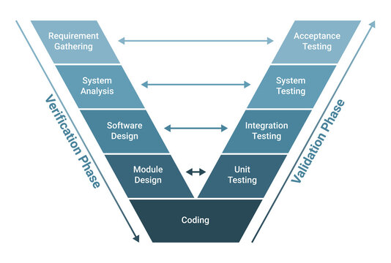

Adobestock.com